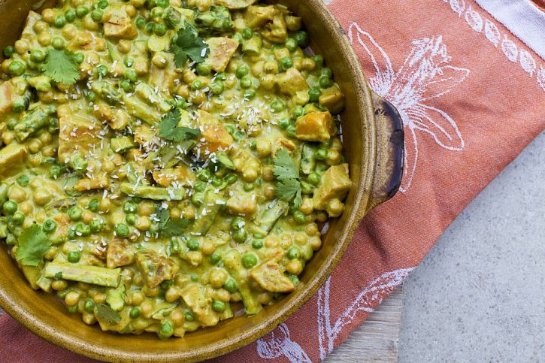

SWEET POTATO & SPINACH KORMA

**14 August 2014**

**This recipe for sweet potato & spinach korma - is one of my favourite ever meals. I first made it for my**[**Recipe Ebook**](http://shop.hipandhealthy.com/collections/e-books/products/hip-healthy-e-recipe-book-in-the-hip-healthy-kitchen)**I created for Hip & Healthy - and since then can’t ever make it enough! It is truly delicious; so creamy, and full of flavour. You can guarantee it’s better for you than any indian takeaway!**

**The sauce is made from a mixture of cashews and coconut which come together to create the cream alternative. We then add the highly anti-inflammatory spice turmeric, cumin, garam masala and a little chilli powder. The spices turn this sauce into an indian delight, and add tons of beneficial nutrients. Instead of the normal chicken in an indian korma we’ve got cubes of sweet potato which acts as the wholesome element of the dish. We then also add chickpeas, peas, asparagus and spinach. I love to garnish this dish with some desiccated coconut, and sprigs of coriander.**

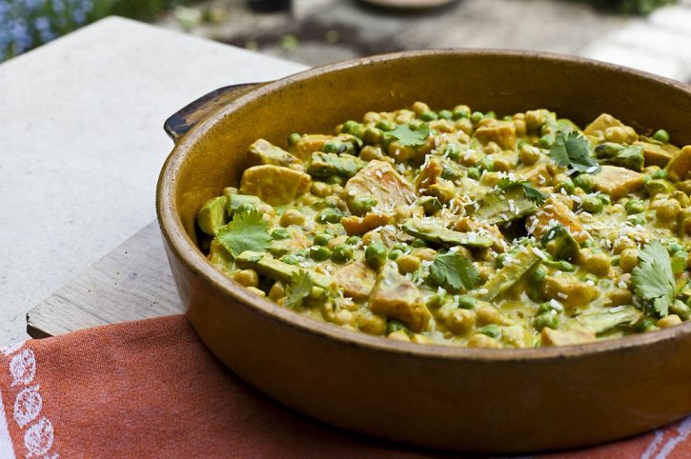

**INGREDIENTS:**

**1/2 cup cashew nuts (soaked)**

**1 cup coconut milk**

**2 tbsp coconut oil**

**1/2 cup water**

**12oz can chickpeas**

**4 cups spinach**

**1 cup peas**

**1 sweet potato pealed and chopped into cubes**

**1 packet asparagus**

**FOR CURRY BASE:**

**1/2 tbsp oil**

**1 tsp garam masala**

**1 tsp cumin powder**

**2 tsp turmeric**

**1/4 tsp chili powder**

METHOD:

**Peal and chop the sweet potatoes. Boil the sweet potatoes for 20 minutes or until soft. In a blender process the cashew nuts, coconut oil, coconut milk, water and curry base. In a wok with a drizzle of olive oil, add all the vegetables continue to stir till soft. Add the korma sauce, heat and serve. Serve with brown rice if desired.**

**- See more at: http://www.naturallysassy.co.uk/recipes/sweet-potato-spinach-korma#sthash.HUVa0DoT.dpuf**